How supervisor can enter time for student/employee
In CORE CT supervisor must use the following navigation steps to navigate to Timesheet :
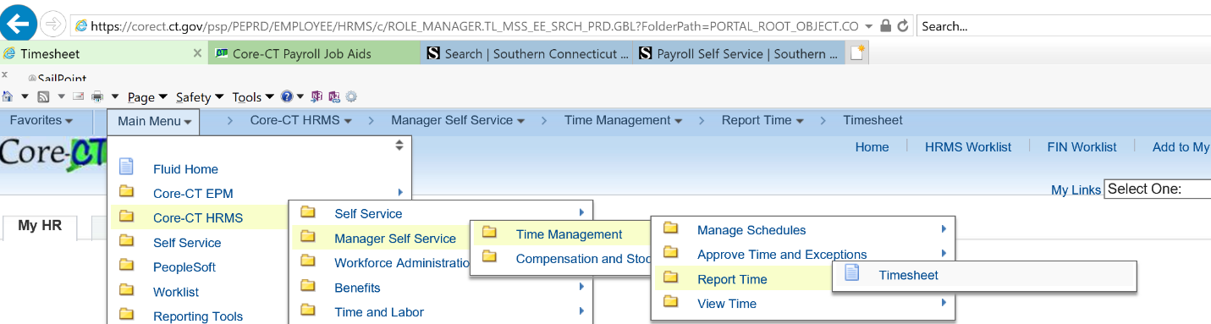

Click on ‘Timesheet’
The system will display Timesheet Summary page.
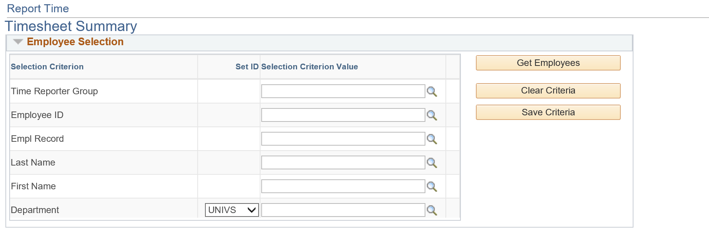
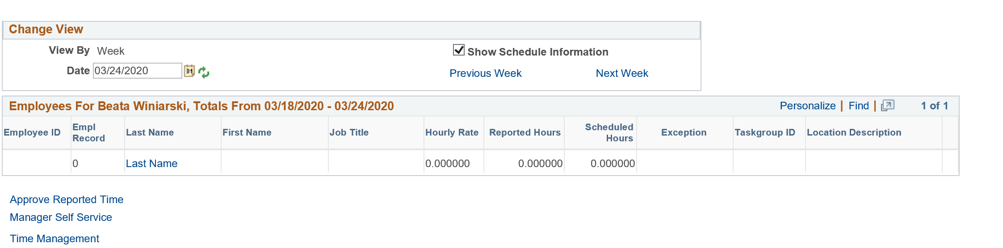
Enter the Employee ID and click ‘Get Employees’ button
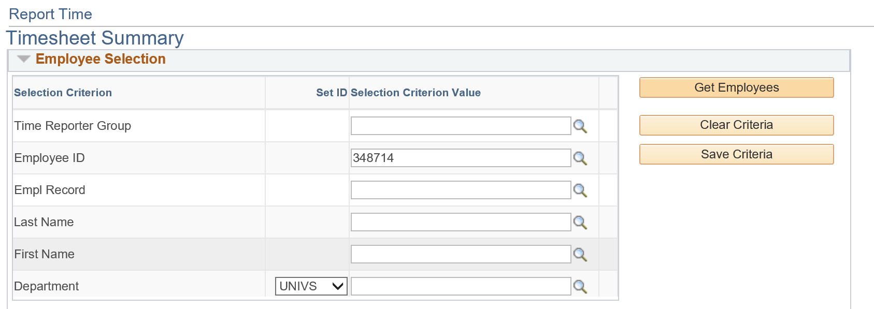
The system will display the student/employee information in the lower section of the screen
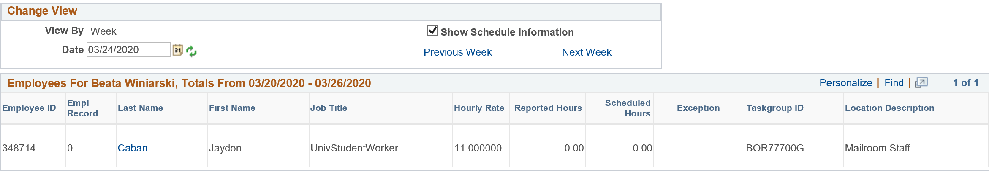
Click on the last name of the employee. (The system will navigate you to the employee timesheet (the system would pull the timesheet based on the date you are accessing it) You can change the date to make sure you are pulling the correct timesheet for the correct pay period.)
The system displays employee timesheet

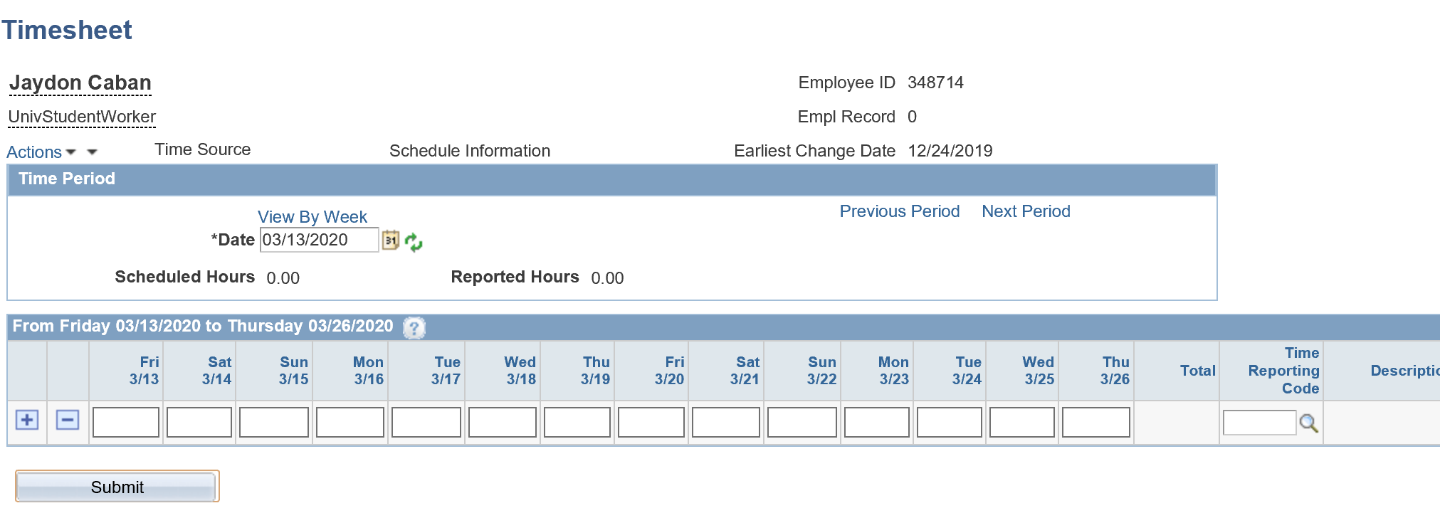
Enter the hours and TRC code associated with the hours and click the ‘Submit’ button

