CSU - AAUP Faculty Research Grants

Guidelines for the Spring 2024 Competition

(Project Performance Period: July 1, 2024, to June 30, 2025)

General Provisions

These Guidelines are drawn from, and are consistent with, the stipulations in Sections 9.10 and 12.10.1 of the document “Collective Bargaining Agreement between Connecticut State University, American Association of University Professors and Board of Regents for Connecticut State Colleges & Universities System, August 27, 2021 – August 26, 2025” and its predecessor.

CSU-AAUP Faculty Research Grant proposals are screened by a Selection Committee comprising 12 faculty members drawn from the four CSU universities and chaired by an ex-officio, non-voting member of the Academic Affairs staff from the CSCU System Office.

Applicants for CSU-AAUP Faculty Research Grants must be full-time members of the faculty and must remain on the faculty of the university originating the proposal for the duration of the grant-supported activity, including the project reporting phase. Faculty planning sabbatical leaves are eligible for a grant. Faculty members on unpaid leave are not eligible to apply. Faculty members are not eligible to apply while serving on the Selection Committee.

These guidelines detail the following: funding priorities, instructions for proposal preparation and submission, proposal review criteria, calendar for proposal submission, review process and announcement of awards (consistent with contractually established schedules), cover sheet to be attached to each proposal.

Priorities

The program seeks quality proposals that enhance the educational mission, visibility, and research stature of the Connecticut State Universities. The CSU-AAUP contract specifies that funds will be used for “research grants”. For the purposes of this program a broad definition of research is adopted. Research is defined as any scholarship activity which results in one or more of the following:

the creation of new knowledge in a particular discipline, including making connections across traditional fields (i.e. multidisciplinary research);

the application of disciplinary/multidisciplinary knowledge, methodologies and/or insights to problems of individuals or groups in the broader society;

the production of creative works in the arts; and

research in student learning within a discipline or area of learning

Curriculum development and faculty development projects will not be funded by the CSU-AAUP Faculty Research Grants program; projects in those areas are best suited for programs supported under sections 9.6 and 10.6.5 of the CSU-AAUP contract.

In addition, proposals submitted to this Faculty Research Grants program should take into account one or more of the following aspects of faculty research:

Establish new research (in the broad definition of the previous paragraph) at the university

Support faculty in the continuation and completion of meritorious research

Encourage the development of projects with potential for external funding

Review Criteria

The AAUP-CSU Faculty Research Grants Selection Committee will use the following criteria to rate the quality and completeness of the proposals submitted:

Significance: Presentation of a well-focused and worthy purpose, per the guideline’s stated Priorities.

Work Plan: An appropriate and feasible methodology and a plan of action and/or conditions that will result in the accomplishment of the objectives of the project in the context of the particular area of research. The plan should be appropriate to the nature and area of research of the proposal and should include a timeline. If funds are being requested to purchase equipment, the proposal should describe the specific activities for which the equipment is needed (grants involving the purchase of equipment should justify such purchase on the basis of the research to be conducted by the author, or each of the authors in a joint proposal, within the period of the grant).

Outcomes and Reporting: A demonstrated publication history and/or an ongoing and documented commitment (in the proposal) to seek publication of the results of research emanating from previous grants under this CSU-AAUP Faculty Research grants program in refereed journals, conference presentations (including campus-based events), performances, exhibits or other measurable and demonstrable means of dissemination of research results. Recognized quality and prestige of the publications/events in the specific field of the proposal will be appropriately weighted by proposal reviewers. Submission of a proposal (and the declared intention to submit the CSU-AAUP Faculty Research grant proposal) to an external agency for funding is a legitimate and encouraged outcome. A final report highlighting the scholarly accomplishments of the research is due 90 days after the completion of any funded project. Reports of joint projects should reflect the contributions of individual participating faculty. Evidence of prior peer-reviewed publications/performances or exhibits resulting from previous CSU-AAUP Faculty Research grant activity will be regarded particularly favorably.

Budget Proposal: Inclusion of a realistic budget (see Appendix A3) that is clearly stated, justified and consistent with items 1 - 3 above.

Review of Proposals by the Selection Committee

For the purposes of grant proposal review, the Committee will divide into three groups of readers each of which will be responsible for reviewing proposals from two universities other than their own. The reviewers from Central and Eastern will be responsible for scoring proposals submitted by faculty members from Southern and Western while the readers from Southern and Western will be responsible for scoring proposals submitted by faculty members from Central and Eastern. Each of these groups will constitute the set of reviewers representing the following broad-based disciplinary groupings in which proposals are categorized: Fine Arts and Humanities; Social Science, Business and Education; and Life and Physical Sciences, Mathematics, Computer Science, and Engineering Technology.

Scoring

Each proposal will be screened at the university where it is originated to verify its completeness and general compliance with the rules stated in the following section of these guidelines. Each proposal will be read by three reviewers drawn from the discipline groupings. Each reviewer will be asked to assign a score from "1" for weak to "5" for excellent for each of the items 1 through 4 listed in the “Review Criteria” section above. The combined scores generated by the three readers should produce a total proposal score ranging from a low of 12 to a high of 60. The selection committee at the university from which each grant was submitted will use these scores as the principal basis to determine which proposals are recommended for funding and their level of funding.

Proposal Components and Rules for Submission

A grant proposal must contain the following components and adhere to the following rules:

Cover Sheet Abstract and Sign-Off Statement:
Please use the exact format provided on Appendix A.1.

Proposal Narrative:
The narrative should be organized using the three headings noted under the “Review Criteria” section above - Significance, Work Plan, and Outcomes and Reporting. Narrative should be limited to about 1200 words in up to five pages of printed text using Times New Roman 12-point (or equivalent) font, in double spaced paragraphs and one inch page margins top, bottom, left and right. For added space allocation permitted in joint proposals please see numeral 7 below. To maintain the limit in number of pages, an appendix with graphics and similar elements is recommended only for cases when they are considered a crucial and necessary part of the application. Cover page, budget pages, curriculum vita(e), footnotes, bibliography, and optional appendices do not count towards the narrative word and page limits. Optional Appendices may be attached at the writer's discretion and should be labeled Appendix B, C, etc. These optional appendices will not be scored, and reviewers will be free to judge their relevance in support of the narrative. Each submission will be scored by a group of peer faculty who are not necessarily specialists in the specific discipline of the proposal. It will be ensured, however, that these readers have the necessary expertise within the broad disciplinary category that the proposer has selected in the application cover sheet (Appendix A.1). It is important to keep in mind that a successful proposal should be written for an informed generalist in the particular discipline grouping to which the proposal belongs. At the same time, it should give enough specific information on the significance of the research and the soundness of the methodology in the context of the particular discipline to allow a reasonable review. A brief outline of related research undertaken by the applicant and/or others will help the reviewers understand the significance of the project. A creative arts proposal should contain a description of the work to be produced, materials and facilities to be used, personnel, and production requirements. All travel supported by this program must be justified and demonstrated essential to the research proposed. For example, if foreign travel is proposed, the proposer must ascertain those collectionsand/or resources needed for the work are not available in the United States. Such strong justification should be included in the proposal narrative and further addressed in the Budget section, Appendix A.3.
Important Requirement: Proposals requesting support for continuation of work previously funded by this program must include a “Report on Previous CSU-AAUP Funded Research” as outlined in Appendix A.2. This summary should include compelling evidence of the impact of the research conducted, such as publications in peer reviewed journals, securing of external funding for the expansion/continuation of the work, presentations at professional conferences, performances or exhibits, book publications, etc. The Report on Previous CSU-AAUP Funded Research should be no more than two pages and should be placed immediately following the narrative section. This report does not count as part of the five-page limit on the proposal narrative.

Proposal Budget:
Proposals must use format and instructions provided in Appendix A.3. Awards are limited to $5,000 per faculty member. A proposal outside the funding limit will be disqualified or, if time allows, be returned to the faculty submitting the proposal for corrections as part of the preliminary screening process conducted at the university originating the proposal. The proposal must show and appropriately justify the relationship between anticipated expenditures and proposed activities. Legitimate budget items include: faculty stipend, support services, supplies and equipment, and research-related travel. If a stipend is part of the budget, the contractual limit of $2,500 per applicant must be followed. Stipends shall be outright and the grant shall be unrestricted. Stipend payments to AAUP members or to CSU university students will be administered following university payroll rules and procedures. All budget figures must be rounded off to whole dollar amounts (no cents).

Two-Page Curriculum Vita(e):
Please include brief vita(e) of no more than two pages highlighting educational background, professional experiences, and scholarly accomplishments of participants. Curriculum Vita(e) in excess of the two-page limit per faculty will be disregarded.

Human Subjects and Vertebrate Animals:
If your research involves either human subjects or the use of vertebrate animals, you must so indicate on the proposal cover sheet. Once a project is funded, the awardee must seek approval from the Institutional Review Board (IRB) for human research subjects or the Institutional Animal Care and Use Committee (IACUC) for vertebrate animals. You should contact the appropriate committee on your campus for information on submission procedures and timing. In no case should work with human beings or vertebrate animals as research subjects be undertaken until the proper approval is obtained. The review of the proposal will include notification to the universities regarding the need for compliance according to the procedures mandated by the IRB or IACUC. Failure to obtain the proper approval may result in the termination of your award and the recovery of any funds awarded for research expenses including stipends. Letters of approval from the IRB or IACUC must be attached to the final report.

Submission of Project Proposal:
For faculty on all campuses except Southern Connecticut State University (SCSU), email proposal as a single Adobe Acrobat (PDF) document no later than Friday, January 26, 2024 by 5:00 p.m. to the administrative representative listed below for your campus:
CSU-AAUP Research Grant University Liaisons
Univ. | Office | Contact | E-Mail address | Phone #
CCSU | Grants and Funded Research | Ms. Brenda Lopez | b.lopez@ccsu.edu | 832-2366
ECSU | Administrative Assistant Academic Affairs | Ms. Pamela Wrinn | wrinnp@easternct.edu | 465-5245
SCSU | Faculty Development | Ms. Jennifer Hudson | SCSU uses an electronic platform for proposal submission; please see appendix for details | 392-5357
WCSU | Provost  Special Assistant to the President | Dr. Missy Alexander  Mr. Paul Steinmetz | alexanderm@wcsu.edu  steinmetzp@wcsu.edu | 837-8400  837-9805

It is essential, for the distribution of proposals to the selection committee, that you follow the file-naming protocol presented below:

DISCIPLINARY GROUPING_LAST NAME_INITIAL_CAMPUS.FILEEXTENSION

For example – FAH_SMITH_J_CCSU.pdf

Abbreviations for the disciplinary groupings are:

Fine Arts & Humanities - FAH

Social Science, Business & Education - SSBE

Life & Physical Sciences, Mathematics, Computer Science, & Engineering Technology - LPMCET

Joint proposals should use the name and disciplinary grouping of the principal contact.

For clarifications regarding the proposal submission process, contact your university liaison.

NOTE: Any proposal submission not following the file-naming protocol will be deemed ineligible unless time allows the applicant to make necessary corrections, at the discretion of the university liaison.

Joint Proposal Conditions:
A joint proposal may be submitted by two or more members of the faculty and may be funded up to the limit of $ 5,000 per faculty member participating in the collaboration. The limit of $2,500 for stipends for each faculty member participating is maintained (that is, although a joint proposal submitted by 2 faculty members may request up to $10,000, each faculty member can only be allocated a maximum of $2,500 for stipends in the budget.) Joint proposals can only be submitted by faculty members from the same university. As explained in section 8. below, in no case will a faculty member be allowed to submit proposals totaling more than the $5,000 funding limit, and $2,500 stipend limit, for any given year of the collective bargaining agreement, regardless of the number of proposals in which that faculty member participates in that year. When these limits are exceeded, the preliminary screening conducted at the university originating the proposal will disqualify it or, if time allows, will result in a request for modifications to comply with these rules. Joint proposals should specify the individual contributions and adequate level of participation by each of the faculty members participating in the collaboration. In order to allow space for this description, the five-page proposal limit is increased by one additional page (up to about 240 additional words of double-spaced printed text) per additional faculty member participating in the collaboration. Collaborative research across the universities is possible, but the components of such work should be submitted by the faculty at each home institution. Proposals will be reviewed separately. It is important to be aware that selection for funding at one university does not guarantee the selection of a related proposal at another university since the request levels, ability to fund and distribution approach may vary from institution to institution as determined by local Grants Committee members during final stages of the review. If funded, all payments will be made at each faculty’s university of affiliation according to the budget submitted in the proposal to that university.

Number of Proposals in Which a Given Faculty Participates:
A faculty member may submit more than one proposal (individually or in collaborations), but the combined funding request for such faculty member shall not exceed $5,000 in a given year. The limit for total stipends for each faculty remains at $2,500, regardless of the number of proposals in which the faculty member participates.

Proposal Checklist
For your convenience, a Proposal Checklist is provided in Appendix A.4. Do not submit this form – the checklist – with your proposal.

IMPORTANT NOTICES

PROPOSALS FAILING TO ADHERE TO ANY OF THE “PROPOSAL COMPONENTS AND RULES FOR SUBMISSION” (ITEMS 1. TO 8. ABOVE) WILL NOT BE REVIEWED

SUBMITTED ELECTRONIC COPIES OF THE PROPOSALS WILL NOT BE RETURNED

FUNDED PROPOSALS MAY BE MADE AVAILABLE FOR EXAMINATION BY INTERESTED PARTIES

Lack of compliance with programmatic or fiscal reporting REQUIREMENTS related to this program will be handled in accordance with THE SPECIFIC university’S procedures

CSU - AAUP Faculty Research Grants

(Project Performance Period: July 1, 2024 to June 30, 2025)

2024-2025 Calendar

Friday, January 26, 2024, by 5:00 p.m.

Deadline for applicants to email project proposal to the designated University Liaison at the faculty member’s home institution, in required format

Proposals not accepted after this closing date and time, except for campus closing

Friday, April 12, 2024, by 5:00 p.m.

Each University’s Grant Selection Committee submits recommendations for funding to the President of the Connecticut State Colleges & Universities System via the System Office’s coordinating staff member. University Liaisons may notify applicants of the Committee’s recommendations for funding which are subject to Board of Regents (BOR) approval.

Friday, April 19, 2024

System office coordinator forwards Selection Committees’ recommendation to

BOR’s Academic and Student Affairs Committee for its consideration.

Friday, May (TBD), 2024

BOR’s Academic and Student Affairs Committee reviews slate of recommendations by the Selection Committee and decides to recommend acceptance or rejection to the entire BOR.

Thursday, May (TBD), 2024

BOR officially approves or rejects recommendations. If approved, an announcement of the awards will follow.

Within three (3) months of the termination date of a grant --no later than Friday, October 6, 2025
Principal contact for each project submits to the University Liaison and to the Academic Vice President at the home university a report describing the results of the research and providing a detailed account of fund expenditures. Any funds unaccounted for shall be returned to the university and be added to the allocation to be distributed in the following year

APPENDIX A

A.1 COVER PAGE FORMAT

A.2 FORMAT FOR REPORTING PREVIOUS CSU/AAUP-FUNDED RESEARCH

A.3 BUDGET AND BUDGET JUSTIFICATION FORM

A.4 PROPOSAL CHECKLIST

Appendix A.1:

2024-2025 CSU-AAUP FACULTY RESEARCH GRANT

PROPOSAL COVER SHEET

Faculty Rank of Principal Contact:
Last Name:
First Name:
University:
Department:
Funding Request: $
Is this a Joint Proposal? Yes No
If Yes, please fill in information for co-proposers (add separate sheets as necessary):

Name__________________________ Rank________________ Department_______________________

Name__________________________ Rank________________ Department______________________

Is this a Continuation Project? Yes No If Yes, you must complete Appendix A.2

E-mail of Principal Contact: Phone Number of Principal Contact:

Campus Address of Principal Contact:

Please select one disciplinary group category in which this project best fits:
Fine Arts and Humanities Social Sciences, Business and Education
Life and Physical Sciences, Mathematics, Computer Science, Engineering and Technology

Please select one research focus area in which this project best fits:
Creation of new knowledge Application of disciplinary/multidisciplinary knowledge, methodologies and/or insights Production of creative works Research in student learning

Project Title:

ABSTRACT (Limit: 100 words)

IRB/IACUC Statement

(If "yes" to either question please see Section 5, p. 3 of the program guidelines)

YES NO

Does your research involve human beings as research subjects?

Does you research involve vertebrate animals?

Sign-Off Statement (To be signed individually by each faculty applicant. Please add separate sheets as needed)

I hereby acknowledge my understanding that the lack of compliance with the proposal format and other requirements spelled out in the CSU - AAUP Faculty Research Grant Guidelines for the Spring 2019 Competition may result in the proposal being disqualified without review.

Signature of Permanent, Full-Time Faculty |  | Date

Signature of Permanent, Full-Time Faculty |  | Date

Signature of Permanent, Full-Time Faculty |  | Date

Appendix A.2:

REPORT ON CONTINUATION PROJECT

CSU-AAUP FUNDED RESEARCH

Proposals requesting support for continuation of work previously funded by this program must include a summary herein. This summary should include compelling evidence of the impact of the research conducted, such as publications in peer reviewed journals, securing of external funding for the expansion/continuation of the work, presentations at professional conferences, performances or exhibits, book publications, etc. The Report on Continuation Project should be no more than two pages.

Note: Lack of compliance with programmatic or fiscal reporting requirements related to this program will be handled in accordance with university procedures.

Appendix A.3:

BUDGET AND BUDGET JUSTIFICATION FORM

2024-2025 CSU - AAUP Faculty Research Grant
Budget Item |  | Amount  (No Cents) | Brief Justification

Faculty Stipend

Support Services *

Supplies and Equipment

Travel
Total |  |  | N/A

* For definition see Section 9.4 of the “Collective Bargaining Agreement between Connecticut State University, American Association of University Professors and Board of Regents for Connecticut State Colleges & Universities System, August 26, 2021 – August 26, 2025”, Section 9.4, pp. 56-57.

Note: This Budget Proposal Form enables you to succinctly describe the proposed expenditures, and their adequacy, appropriateness and importance. Please keep in mind that the extent to which a justification for proposed expenditures is provided is incorporated in the scoring used during proposal review. The “Amount” column delineates the requested amounts in whole dollar figures. In the “Brief Justification” column please provide a general for each cost, (e.g., name equipment purchased, provide approximate number of hours and hourly rate for student assistants). In the space below, please provide up to about 100 words of text with further details making a case for the proposed expenditures. In particular, justification for research-related travel is important. Proponents are reminded that each university receives a separate Special Funds travel allocation for this purpose.

Appendix A.4:

PROPOSAL CHECKLIST
Before submitting your proposal, please use the following checklist to ensure you are including each of critical pieces of your application in the following order and within basic guidelines:

- Cover Sheet
  - All the following boxes are marked appropriately
    - Is this a Joint Application?
    - Is this a Continuation Project?
    - What disciplinary group best fits proposed project?
    - What research focus best fits proposed project?
    - IRB/IACUS statement boxes
  - Abstract is 100 words or less
  - The form is signed and dated by each participating faculty member.

- Narrative
  - The text is double-spaced and written in Times New Roman 12 pt. or equivalent font.
  - The narrative is no longer than about 1200 words (for joint proposals, up to about 240 additional words in one page are permitted per additional participating faculty member). The printed narrative should not be longer than 5 pages including Significance, Work Plan, and Outcomes and Reporting. For joint proposals an additional double-spaced page is permitted per participating faculty member.
  - The required headings are used to organize the narrative (Significance, Work Plan, and Outcomes and Reporting)
  - Report on Previous Related CSU/AAUP-Funded Research Form immediately follows the narrative if this proposal is a continuation

- Proposed Budget
  - Proposal Budget Form must be used
  - Is the budget reasonable for the proposed work?

- Curriculum vita
  - Vita is no more than 2 pages per applicant.

- Appendix (optional, as needed)
  - Any optional appendix should follow the vita(e)
  - Limited to 3 pages

CSU-AAUP Faculty Research Grants
Guidelines for Spring 2024 Competition
Special Instructions ONLY for Southern Connecticut State University Faculty

Submit through Kuali Build
The following instructions are meant to amend the directions regarding submission of the CSU-AAUP Faculty Research Grants for the Spring 2024 Competition.

All submissions by Southern Connecticut State University faculty members for the Spring 2024 CSU-AAUP Competition (Performance Period July 1, 2024 – June 30, 2025) must be shared with the Office of Faculty Development through submission of an electronic application in Kuali Build.

Please do not submit your materials via email.

Instructions for each portion of the form are as follows.
Cover Sheet
The form on Kuali Build is intended to exactly replicate the information provided via the traditional CSU-AAUP Faculty Research Grant Cover Sheet. The screenshots below are meant to be samples and may look slightly different during the application process.

The first section relates to basic contact information such as the faculty member’s name, rank, phone number, and campus address. Selecting ‘Yes’ in answer to the question ‘Is this a joint proposal?’ will cause additional fields to appear; this is the place where more names can be entered related to Co-Proposers.
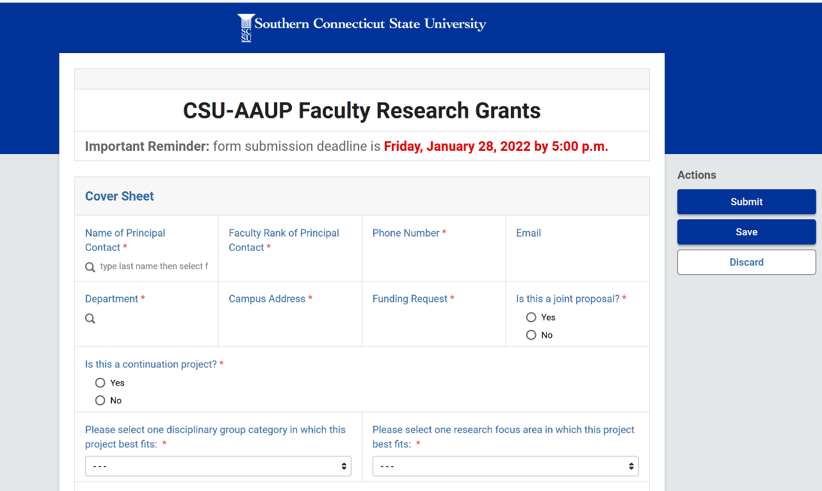
If you select ‘Yes’ in answer to the question ‘Is this a continuation project?’ then the following additional field will appear. Please upload an attachment summarizing results of your previous CSU-AAUP funding.
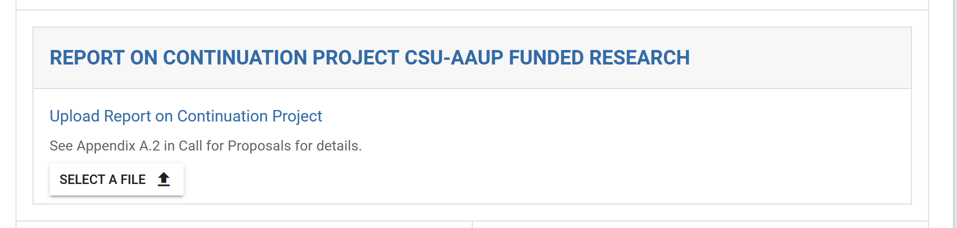

The next section of the form will allow you to enter a title (150 characters maximum, including spaces) and an abstract (100 words total). Selecting ‘Yes’ to the question ‘Does your research involve human beings as research subjects’ and/or ‘Does your research involve vertebrate animals?’ will cause additional instructions to appear regarding IRB and IACUC policies and institutional points of contact.
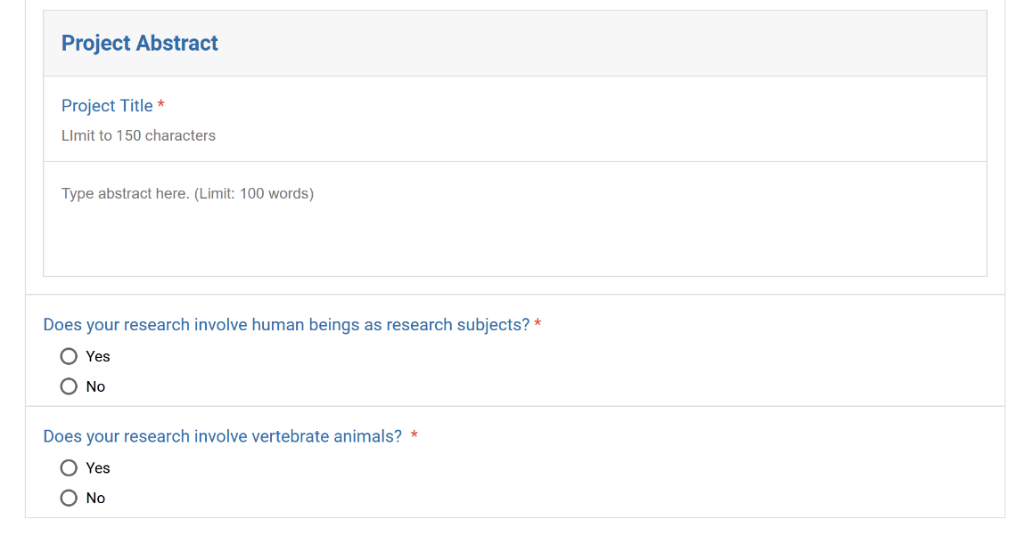
The final section provides a space to upload the CSU-AAUP attachments that are detailed further in the CSU-AAUP funding opportunity announcement: a Budget Form (required), a Proposal Narrative (required), a CV of the Principal Contact (required), and Appendices (optional). A space is also provided for the CVs of optional Co-Proposers. Uploads may be as PDFs, .DOCXs, or .DOCs.
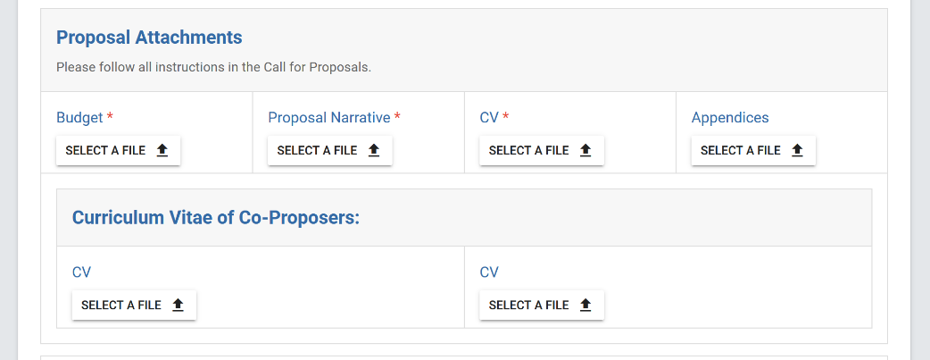
There are several options on the right-hand menu [at the top of the page] when you have finished working on the application:
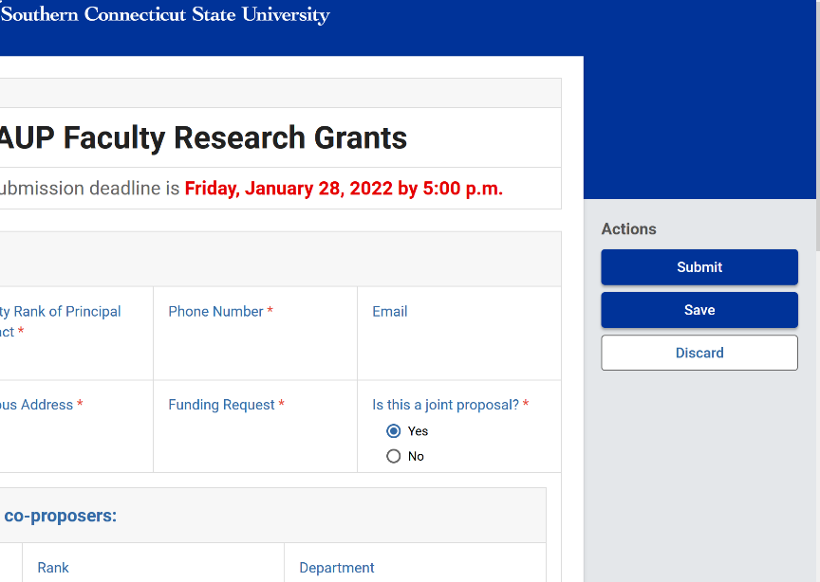

‘Submit’ will send the form and attachments forward to the SCSU Office of Faculty Development for final acceptance and processing. You will receive a notification when this proposal is received and approved, OR if it is incomplete and is denied.

‘Save’ will not submit the form, and a draft will be accessible to you when you visit the Kuali Build Home Page. To return to your drafted applications that have not yet been submitted, please select ‘Submissions.’ There will be a space to select between ‘Submitted’ and ‘Drafts.’

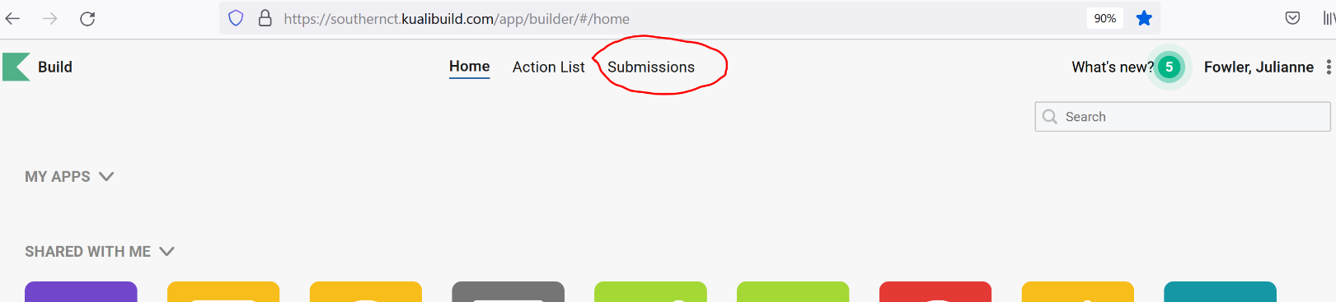

Select ‘Discard’ only if you wish to clear the application form and start over.

NOTE: If you would like to correct an application prior to the January 26th, 2024 deadline, please resubmit the application using Kuali Build. In keeping with standard grant practices, the application with the most recent timestamp will be the only application that moves forward for review. Corrections or revisions received after the January 26, 2024 5:00 PM deadline will not be accepted.

- Please contact Jennifer Hudson (hudsonj1@southernct.edu) with questions related to the proposal content and formatting of attachments.
- Please contact spar@southernct.edu with questions related to technical difficulties or form troubleshooting

