Research Associate - Biochemistry/Biophysics
Halda Therapeutics – New Haven BioPharma Company

Halda Therapeutics is a venture-backed biotechnology platform company. Halda is focused on the discovery of precision medicines through the creation of innovative heterobifunctional molecules that modify disease-causing pathways. Halda was founded by Professor Craig Crews from Yale University and is funded by top-tier venture capital firms. The Company is located in Branford, CT and will be moving to new lab space in New Haven, CT in the first quarter 2021.

The Position
The Research Associate should have a strong foundation in protein biochemistry and biophysics and experience contributing to lead discovery and ligand validation efforts. The successful candidate will work within specific discovery project teams that contribute to the development of multiple heterodimerization platforms. This work will require cross-disciplinary interactions with biologists, medicinal chemists, and structural biologists.

Key Responsibilities
- Design and execute robust biochemical and biophysical assays to determine protein-ligand affinity, extent of ligand-induced protein-protein interaction, as well as ligand mechanism of action
- Analyze and interpret assay data and communicate data to team members as well as document in electronic lab notebook
- Troubleshoot assays when necessary
- Collaborate with external collaborators, e.g., CROs, as needed
- Design and execute cell-based assays, as needed

Qualifications
- B.S./M.S. with 2+ years of experience in a biotech or pharmaceutical company
- Experience in developing assays to monitor protein-protein interactions
- Willingness to learn cell-based experiments and methodology
- Ability to thrive in a multifunctional role at a fast-growing biotech
- Excellent interpersonal, communication, organizational, teamwork, time management, and planning skills to accomplish multiple tasks in a short timeframe are essential
- Strong work ethic, responsibility and positive work habits are critical

Additional Desired Qualifications
- Experience with at least one or more of the following quantitative methods to investigate protein/small-molecule or protein/protein interactions: SPR, NMR, ITC, DSF, or fluorescent plate-based assays, such as AlphaLISA, TR-FRET, or FP
- Specific experience with SPR is highly desirable but not absolutely required

This opportunity is facilitated by BioPath, a CT biotechnology careers program. Please mention BioPath when applying.

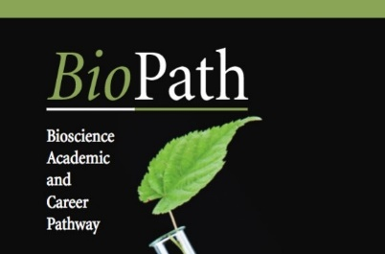
23 Business Park Drive Branford, CT 06405

